**SOFTWARE UNIT TESTING REPORT**

**NAME: SAI CHANDANA THUMMA**

**STUDENT NO: S362823**

**SUBMIT TO: CHARLES YEO**

Table of Contents

1. Introduction 3

2. Process 3

3. Conclusion 5

# 1. Introduction

The major purpose of this specific project is to design a ***"Guess the Number"*** game by employing ***“Test Driven Development (TDD) principles”***. In particular, this game permits players to assume a haphazardly developed four-digit number as well as deliver feedback depending on their guesses. In order to assure code correctness as well as maintainability, it can use the built-in “unittest” framework for the generation of automated unit testing. Thus, this framework permits the user to write as well as execute test cases which can demonstrate the correctness of particular components of the proposed program. Moreover, it assists ensure that the code performs as intended as well as remains functional that making changes.

The objectives are:

* To generate randomly a “four-digit number”.
* To deliver feedback utilizing “circle” as well as “x” symbols.
* To show the number of attempts accepted.
* To permit players to “play again” or “quit the game”.

# 2. Process

The implementation of the logic of the “Guess The Number game” has been performed functionally by following step by step properly that can adhere to the “TDD approach”.

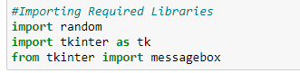

**Figure 2.1: Import the required libraries**

This figure is showing that the required libraries have been imported to execute the further program. Random and tkinter are used for generating random numbers and creating a “GUI interface”.

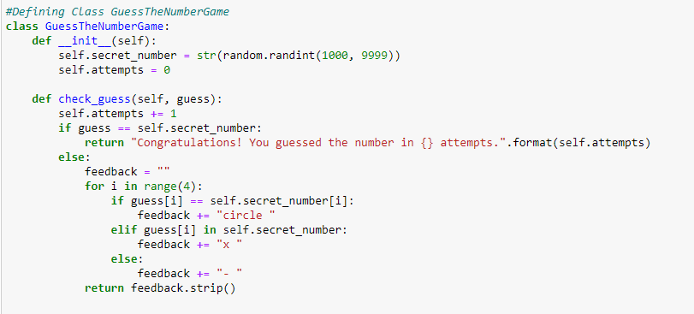

**Figure 2.2: Define the Class GuessTheNumberGame**

This figure is showing that the ***“GuessTheNumberGame”*** class has demonstrated the appropriate logic based on the proposed game. Also, it has initialized a four-digit number randomly considered as the ***“secret number”*** and kept track of that number by assuming “attempts” are taken (Guspianto *et al.* 2023). It has used two specific methods through which guesses are taken as input and also returns feedback regarding the guess accuracy. When the “guess is correct” it produces a congratulatory message along with the “number of attempts” accepted (Eberle, 2023). And when the “guess is incorrect”, it compares the individual digit of that guess with the interrelated digit in the ***“secret number”*** in order to deliver feedback utilizing “circle” as well as “x” symbols.

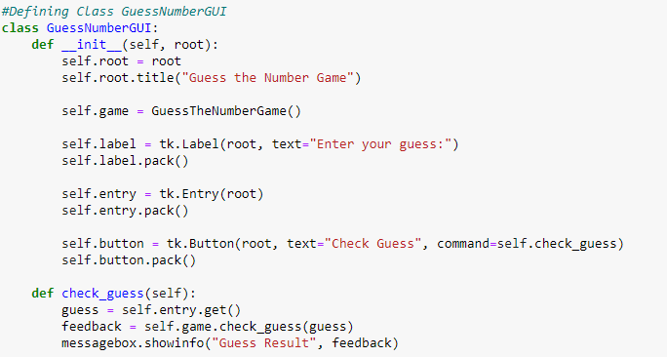

**Figure 2.3: Define the class GuessNumberGUI**

The above figure has shown that the class “GuessNumberGUI” has been defined to create the “graphical user interface (GUI)” for the development of a game utilising Tkinter. On the other hand, the ***“__init__ method”*** creates the effective “GUI” elements in the ***“main window (root)”***. Moreover, it produces a ***“GuessTheNumberGame”*** instance (“self. game”) in order to address the presented game logic. Therefore, ***a label widget (“self. label”)*** shows the “instruction to the user” (Keebler *et al.* 2020). Then ***an entry widget (“self. entry”)*** permits the user in providing the input of their guess. Lastly, ***a button widget (“self. button”)*** initiates the ***“check guess”*** method if clicked. Therefore, it recovers the guess of the user from the “entry widget” and gives it to the proposed game's ***“check guess”*** method. The feedback has been displayed by utilizing the message box ***(“messagebox.showinfo”).***

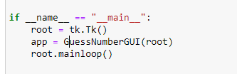

**Figure 2.4: Execution of the Program**

This figure shows that the “main execution block” produces an instance by using the ***“Tkinter (Tk) class”***, which has represented the ***“main application window (“root”)”***.

# 3. Conclusion

Conclusively, the user has developed successfully a ***"Guess the Number"*** game through the approach of “Test Driven Development” that has fulfilled the stipulated requirements. After implementing the "Guess the Number" game based on a simple GUI where users interact with the specified game utilizing the delivered GUI elements. Therefore, this particular approach permitted the user to develop well-tested and reliable code that concentrates on writing tests before executing the implied functionality. Thus, the “automated unit testing tool”, “unit test”, has played an essential role in confirming the accuracy of the code.

**References**

Eberle, B., 2023. Scamper: Creative Games and Activities for Imagination Development (Combined ed., Grades 2-8). Taylor & Francis.

Guspianto, G., Nina, E.Y., Mohamad, I. and Shabira, D., 2023. Development of Health Educational Game Application “Worm Free” Based on Android. JAMBI MEDICAL JOURNAL" Jurnal Kedokteran dan Kesehatan", 11(2), pp.123-135.

Keebler, J.R., Shelstad, W.J., Smith, D.C., Chaparro, B.S. and Phan, M.H., 2020. Validation of the GUESS-18: a short version of the Game User Experience Satisfaction Scale (GUESS). Journal of Usability Studies, 16(1), p.49.